1.2
1.
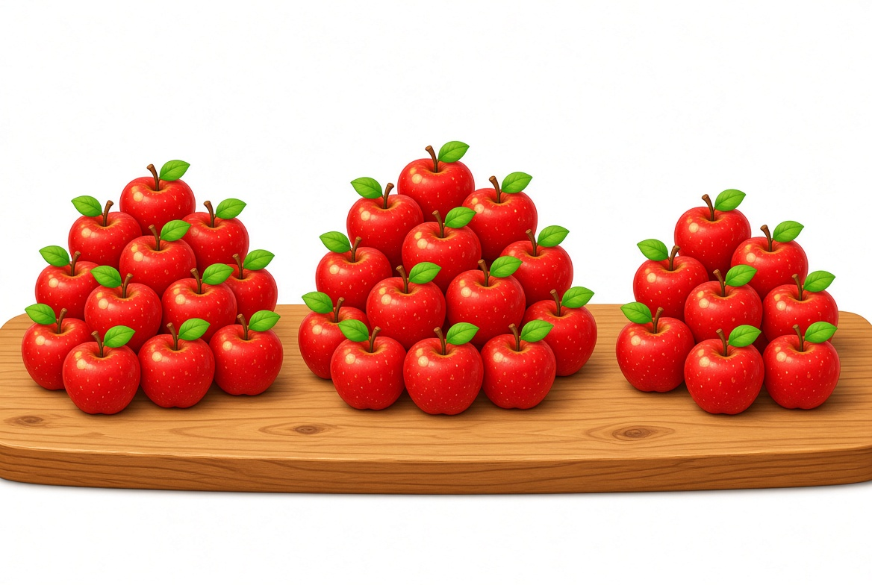
Uzb: Stolda 20 ta, 16 ta va 18 ta olma. Hammasi nechta?
Rus: На столе 20, 16 и 18 яблок. Сколько всего?
Eng: There are 20, 16 and 18 apples. How many in all?
A) 54
B) 44
C) 64
D) 50
2.
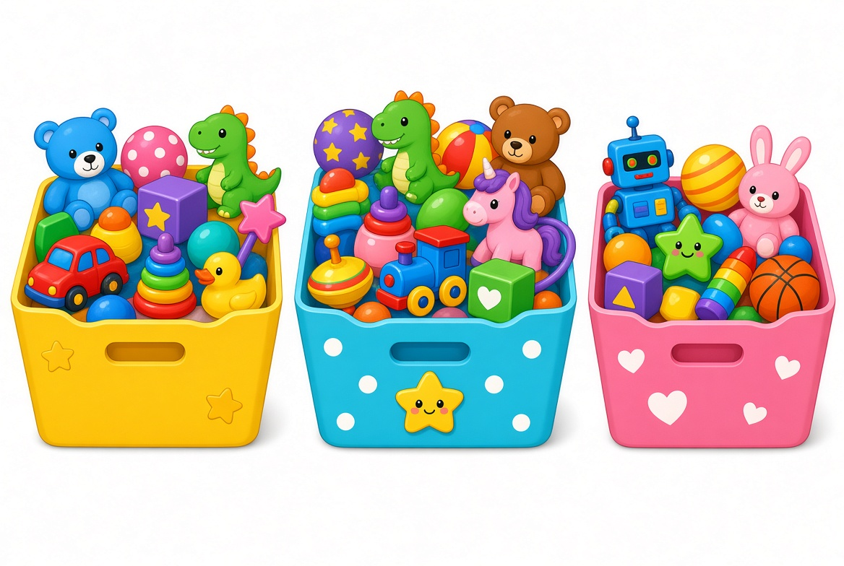
Uzb: Qutida 30 ta o‘yinchoq bor edi. 12 tasi olindi. Nechta qoldi?
Rus: В коробке было 30 игрушек. Взяли 12. Сколько осталось?
Eng: There were 30 toys. 12 were taken. How many are left?
A) 18
B) 16
C) 22
D) 14
3.
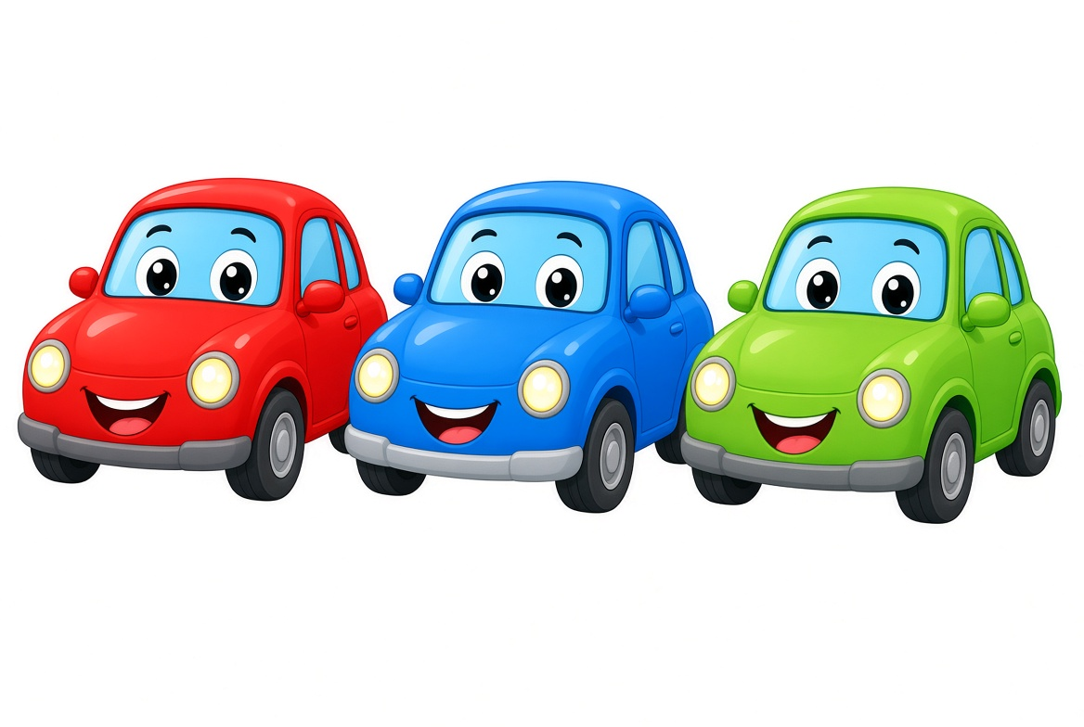
Uzb: 17 ta + 23 ta − 8 ta = ?
Rus: 17 + 23 − 8 = ?
Eng: 17 + 23 − 8 = ?
A) 32
B) 28
C) 36
D) 30
4.
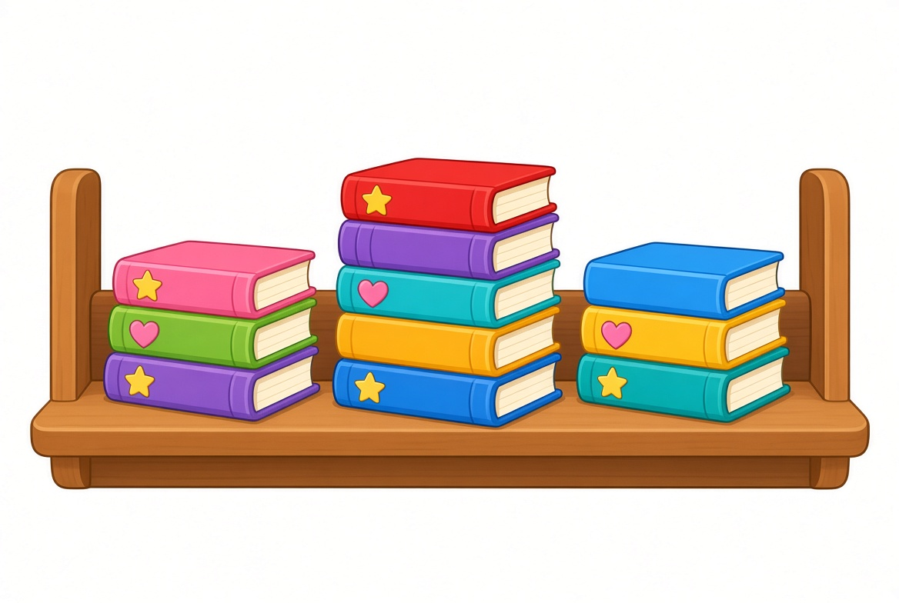
Uzb: Bir javonda 25 ta, ikkinchisida 19 ta kitob. Jami nechta?
Rus: На одной полке 25 книг, на второй 19. Сколько всего?
Eng: One shelf has 25 books, the second 19. How many in all?
A) 34
B) 44
C) 54
D) 40
5.
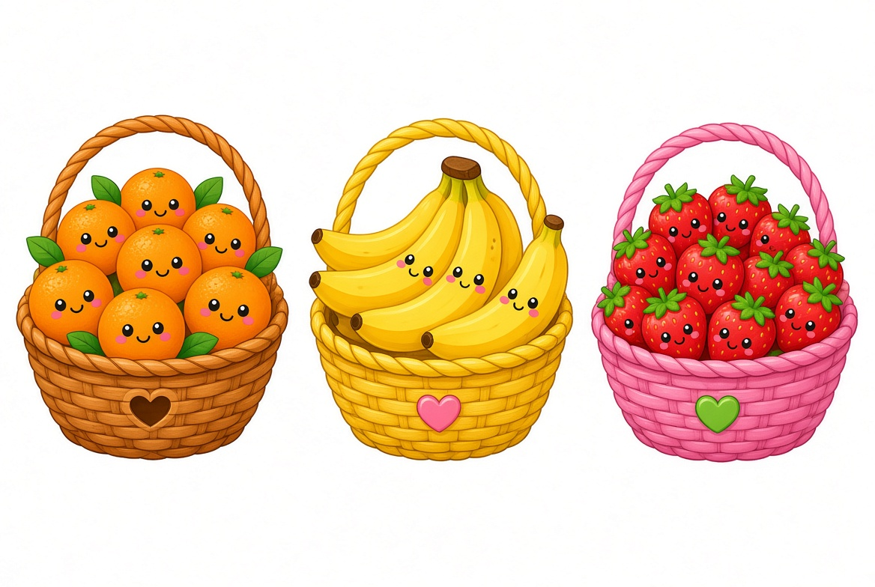
Uzb: 35 ta meva bor edi. 16 tasi yeyildi. Nechta qoldi?
Rus: Было 35 фруктов. Съели 16. Сколько осталось?
Eng: There were 35 fruits. 16 were eaten. How many are left?
A) 19
B) 17
C) 21
D) 15
6.
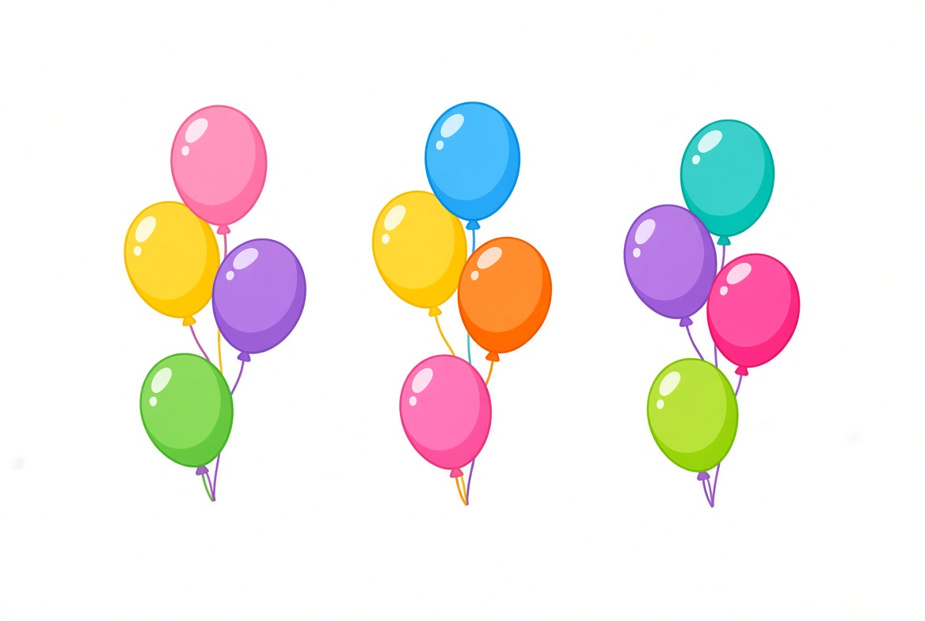
Uzb: 12 ta, 15 ta va 18 ta sharchik. Hammasi nechta?
Rus: 12, 15 и 18 шариков. Сколько всего?
Eng: 12, 15 and 18 balloons. How many in all?
A) 35
B) 45
C) 55
D) 40
7.
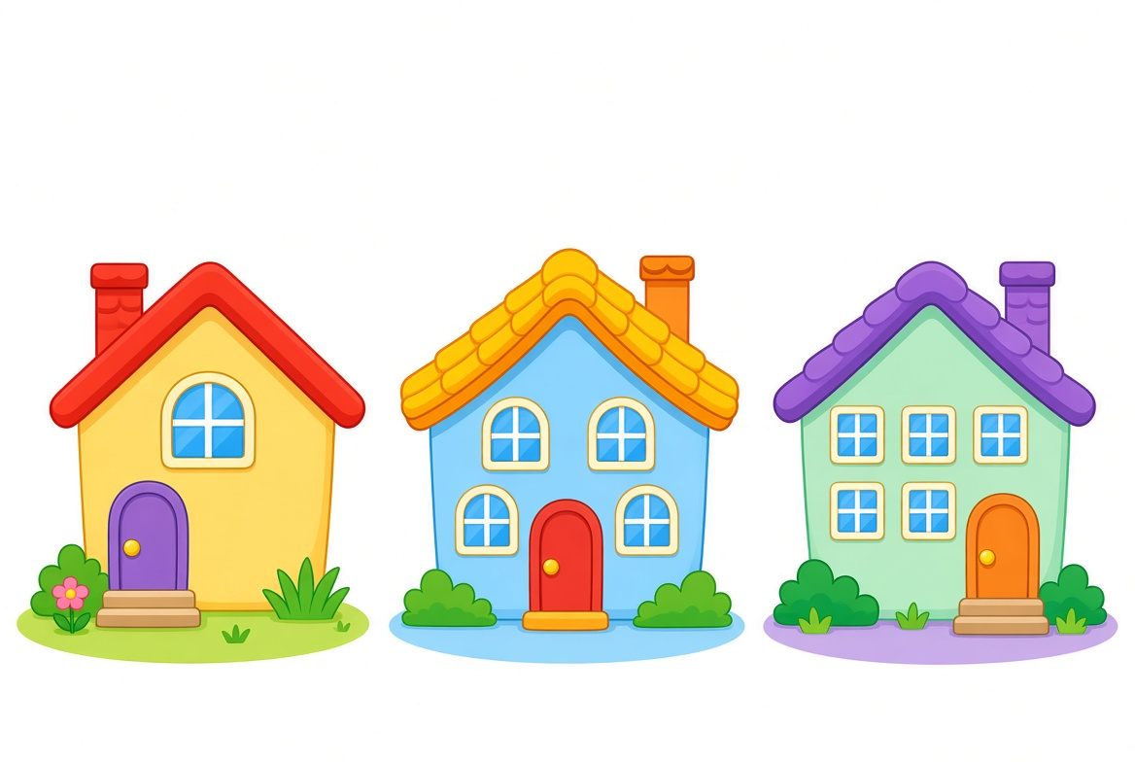
Uzb: Bir uyda 28 ta, ikkinchisida 22 ta deraza. Birinchidan 10 ta yopildi. Qolgan derazalar jami?
Rus: В одном доме 28 окон, во втором 22. Закрыли 10. Сколько окон осталось всего?
Eng: One house has 28 windows, the second 22. 10 were closed. How many remain in all?
A) 40
B) 38
C) 42
D) 36
8.
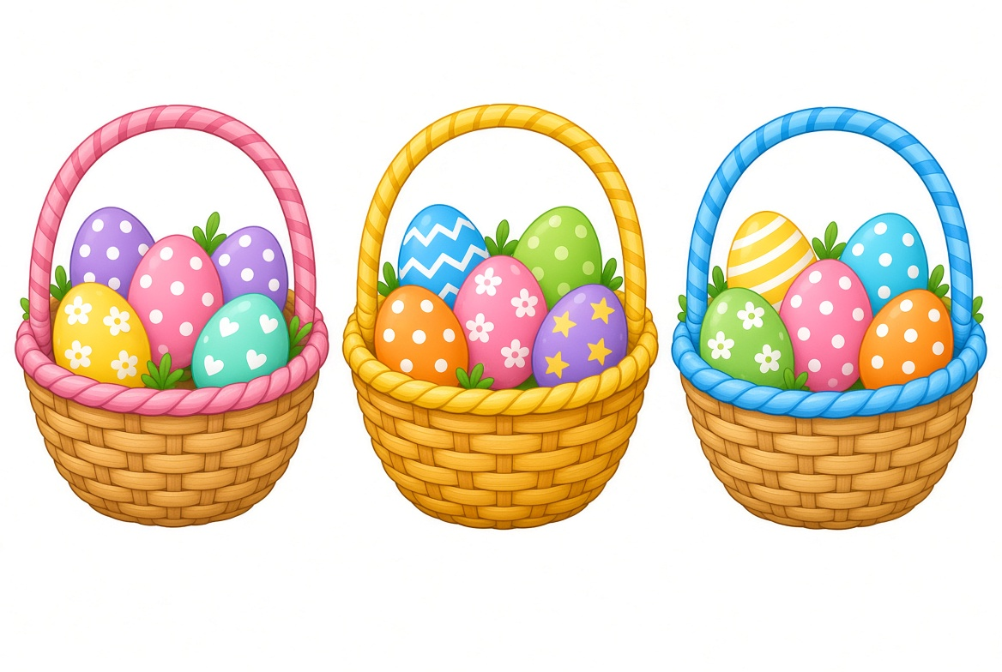
Uzb: Uch savatda 21, 17 va 14 ta tuxum. Har biridan 3 tadan olindi. Qolgani?
Rus: В трёх корзинах 21, 17 и 14 яиц. Из каждой взяли по 3. Сколько осталось?
Eng: Three baskets have 21, 17 and 14 eggs. 3 taken from each. How many remain?
A) 43
B) 37
C) 49
D) 34
9.
Uzb: 45 ta olma bor edi. 18 tasi berildi, keyin 9 ta keldi. Endi nechta?
Rus: Было 45 яблок. Отдали 18, потом пришло 9. Сколько сейчас?
Eng: There were 45 apples. 18 were given away, then 9 arrived. How many now?
A) 36
B) 34
C) 38
D) 32
10.
Uzb: 16 ta + 24 ta − 11 ta = ?
Rus: 16 + 24 − 11 = ?
Eng: 16 + 24 − 11 = ?
A) 29
B) 27
C) 31
D) 25
11.
Uzb: Qizil mashinada 20 bola, ko‘kda 15, yashilda 13. Hammasi nechta?
Rus: В красной 20 детей, в синей 15, в зелёной 13. Сколько всего?
Eng: Red car has 20 children, blue 15, green 13. How many in all?
A) 38
B) 48
C) 58
D) 42
12.
Uzb: 32 ta kitob bor edi. 14 tasi o‘qildi. Nechta qoldi?
Rus: Было 32 книги. Прочитали 14. Сколько осталось?
Eng: There were 32 books. 14 were read. How many are left?
A) 18
B) 16
C) 22
D) 20
13.
Uzb: 22 ta, 19 ta va 15 ta meva. Jami nechta?
Rus: 22, 19 и 15 фруктов. Сколько всего?
Eng: 22, 19 and 15 fruits. How many in all?
A) 46
B) 56
C) 66
D) 50
14.
Uzb: 28 ta sharchik bor edi. 9 tasi uchib ketdi. Nechta qoldi?
Rus: Было 28 шариков. 9 улетели. Сколько осталось?
Eng: There were 28 balloons. 9 flew away. How many are left?
A) 19
B) 17
C) 21
D) 15
15.
Uzb: Bir uyda 26 ta, ikkinchisida 18 ta, uchinchisida 14 ta deraza. Hammasi nechta?
Rus: В одном доме 26 окон, во втором 18, в третьем 14. Сколько всего?
Eng: One house has 26 windows, the second 18, the third 14. How many in all?
A) 48
B) 58
C) 68
D) 52
16.
Uzb: 40 ta tuxum bor edi. 12 tasi ishlatildi. Nechta qoldi?
Rus: Было 40 яиц. Использовали 12. Сколько осталось?
Eng: There were 40 eggs. 12 were used. How many are left?
A) 28
B) 26
C) 32
D) 24
17.
Uzb: 18 ta + 27 ta − 13 ta = ?
Rus: 18 + 27 − 13 = ?
Eng: 18 + 27 − 13 = ?
A) 32
B) 30
C) 34
D) 28
18.
Uzb: Qutida 36 ta, 24 ta va 12 ta. Eng katta qutidan eng kichigini ayiring.
Rus: В коробках 36, 24 и 12. Наибольшая минус наименьшая?
Eng: Boxes have 36, 24 and 12. Largest minus the smallest?
A) 24
B) 20
C) 28
D) 16
19.
Uzb: 30 ta bola bor edi. 11 tasi tushdi, 7 tasi chiqdi. Endi nechta?
Rus: Было 30 детей. 11 вышли, 7 сели. Сколько сейчас?
Eng: There were 30 children. 11 got off, 7 got on. How many now?
A) 26
B) 24
C) 28
D) 22
20.
Uzb: 21 ta kitob + 19 ta kitob − 8 ta kitob = ?
Rus: 21 книга + 19 книг − 8 книг = ?
Eng: 21 books + 19 books − 8 books = ?
A) 32
B) 30
C) 34
D) 28

Javoblar kaliti / Ключ ответов / Answer key
1-A 2-C 3-B 4-D 5-A
6-C 7-B 8-A 9-D 10-C
11-B 12-A 13-C 14-D 15-B
16-A 17-C 18-D 19-A 20-B

